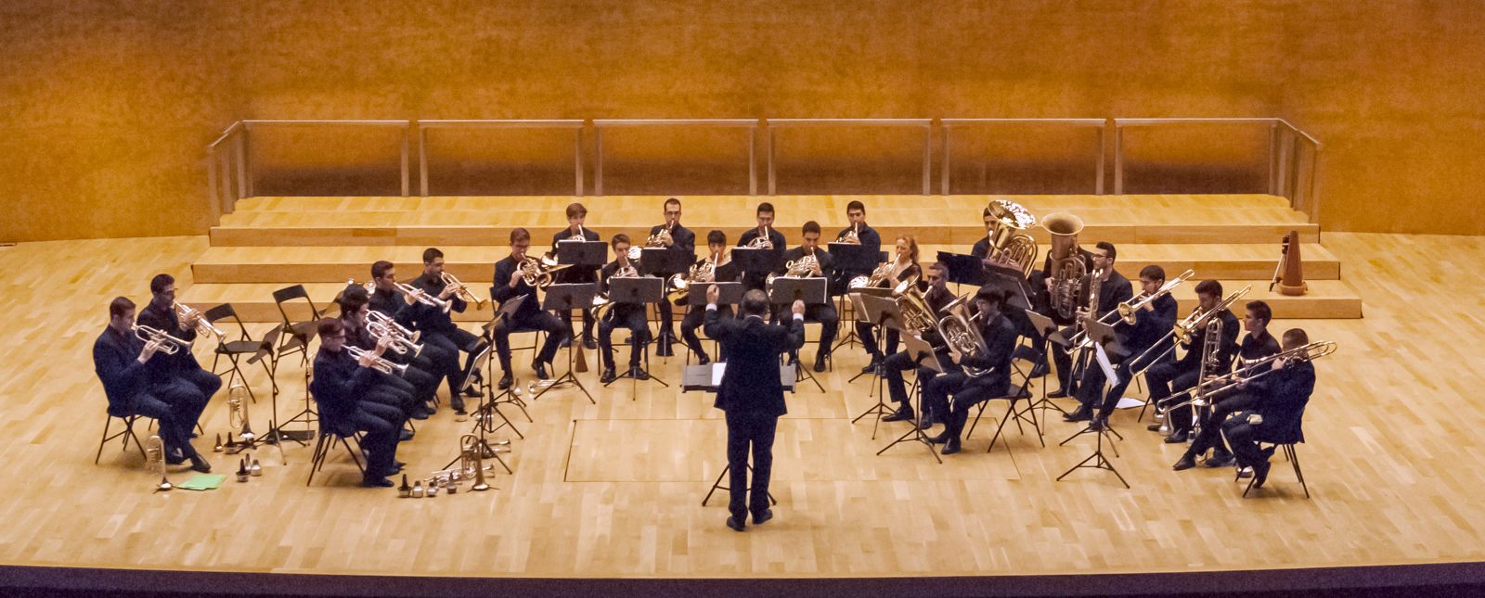
INTERNATIONAL BRASS ACADEMY
Alicante / Spain
The Brass Academy Alicante was founded by Rudolf Korp and Nury Guarnaschelli in 2008 as a private and international academy with the sole aim of offering education of the highest calibre to young brass players. The students collaborate and develop their talent under the tutorage of experienced professors of international standing as a complement to their conservatoire studies nationally or to enhance their playing abilities before embarking on their batchelor or master studies. The BAA also counts exisiting professionals in its complement of students offering advanced post study training.

The academy’s activities take place at our centre, around our centre located in the city of Alicante having a history of offering local, national and international students the opportunity to deepen their instrumental studies in intimate surroundings whilst allowing participants the possibility of working together with top orchestral musicians and professors from across Europe.

The Brass Academy Alicante has contributed to the professional development of many young brass players, providing them with sound basic concepts and the advanced músical criteria necessary for them to go on to be active as soloists, chamber musicians and members of professional symphony orchestras and wind ensembles throughout the world. We aim to provide them with the tools to maintain their playing during a long career atonomously and furthermore the clarity of concept needed for them to pass on their knowledge to future students.

The Brass Academy Alicante includes amongst its numerous honorary patrons outstanding musicians such as Claudio Abbado,Placido Domingo, Leo Nucci, Raul Gimenez,Francisco Casanova, Jose Carli, Josep Caballe Domenech,Dale Clevenger, Steven Mead, Enrique Crespo and Marcelo Abbado.

The Brass Academy Alicante has also had an official collaboration with the Reina Sofia School of Music in Madrid since 2009. The BAA provides students of trumpet, horn, trombone, euphonium and tuba for the numerous concerts and activities at the Santander Festival Music Festival undertaken by this internationally recognised institution.

The BAA has collaborated officially with the local government of Alicante since 2012 offering concerts by the various ensembles of the school throughout the región of Alicante and beyond. Whatsmore the Academy has also presented its Summer Brass Festival since 2012 in conjunction with the Alicante Ayuntamiento (town hall).

Scholarships
One of the centrepieces of the Brass Academy initiative is its extensive program of scholarships. Every year the BAA awards half or complete scholarhips to 50 students from Spain and beyond, supporting young musicians of exceptional talent irrespective of their economical situation. As a result the social project of the BAA plays an important part in Spanish culture, all this achieved inspite of being a private organisation without state support.

Principles and values

- Professionalisim and artistic excellence
- Holistic preparation of young musicians for their integration in professional symphony orchestras and wind bands
- International projection

Through a combination of academic excellence and development of artistic sensitivity the BAA supports the future of talented young musicians in Spain and further afield. We aim to equip our students with everything they need to tackle future careers on the most demanding stages of the world.

Main Activities
The Brass Academy consists of the following faculties:

Trumpet, Horn, Trombone, Euphonium, Tuba, Chamber Music, Orchestral repertoire.

Professors affiliated to the BAA
Rudi Korp - Trumpet
(Director BAA Brass Ensemble)
Vienna Brass-Ex Principle Tonkunstler Orchestra Vienna, Vienna State Opera

Martin Angerer – Trumpet
Principal Symphony Orchestra of the Bavarian Radio

Nury Guarnaschelli – Horn
Vienna Brass-International Soloist-Ex Principal Austrian Radio Orchestra, Stuttgart Philharmonic

Matias Piñeira – Horn
Munich Philharmonic

Stefan Dohr – Horn
Berlin Philharmonic

Paulo Muñoz – Horn
Tonhalle Orchestra Zurich

Adrian Diaz – Horn
NDR Elbephilharmonie Orchestra

Ian Bousfield – Trombone
Ex Principle Viena Philharmonic and London Symphony Orchestra,Profesor Bern University, international soloist

Daniel Perpiñan – Trombone
Ex principle Bilbao Symphony Orchestra, Professor ESMUC in Barcelona

Mark Hampson – Trombone
Mahler Chamber Orchestra, Lucerne Festival Orchestra, Tutor University Franz Liszt Weimar

Csaba Wagner – Trombone
Symphony Orchestra of the Bavarian Radio

Patricio Consentino – Tuba
Principle Buenos Aires Symphony Orchestra,International Soloist

Jose Martinez – Tuba
National Orchestra of Spain

Furthermore the BAA offers diverse intensive courses with invited professors of internation repute from leading orchestras such as the Berlin Philharmonic, London Symphony Orchestra, Chicago Symphony etc.

* Artistic agenda
Musical performances in an ensemble context are a fundamental element of our work and complementary to individual classes. We see this as vital to a young musicians preparation for professional performance.

For this reason, the concert performances infront of live audiences are central to our program at the BAA:

To this end we prepare a variety of performances every academic year, the realisation of which allows all students to establish links to discerning audiences.

YOUTH ORCHESTRA and ACADEMY SUCCESS OF BAA STUDENTS
Gustav Mahler Youth Orchestra GMJO
- European Union Youth Orchestra EUYO
- Schleswig Holstein Festival Orchestra
- Spanish National Youth Orchestra JONDE
- West East Divan Orchestra
- Dutch Youth Orchestra NYO
- Youth Orchestra of the Americas YOA
- Academy of the Suisse Romand Orchestra in Geneva
- Academy of Orchestra of Santa Cecilia, Rome
- Santander Youth Orchestra JOSCAN
- Madrid Youth Orchestra JORCAM
- Murcia Youth Orchestra
- Extremadura Youth Orchestra
- Alicante University Philharmonic
- World Youth Orchestra Jeunesse Musical
- Alicante Youth Orchestra OJPA

Chamber ensembles of the Brass Academy Alicante
* ENSEMBLE BRASS ACADEMY ALICANTE
The brass ensemble was created in 2008 and gives further performing opportunities to the most advanced students of the BAA. Rudi Korp is the director of the ensemble, also trumpet professor of the academy, Mr. Korp benefits from a long and succesful career as a founder member of “Vienna Brass”. The ensemble is in a large format including all the instruments active in the academy.

Thanks to the training received in the group, many of its members have gone on to win places in professional outfits in Europe and beyond including: German Radio Philharmonic Saarbrucken, Helsinki Philharmonic, Gustav Mahler Youth Orchestra, Spanish National Youth Orchestra, Finnish National Opera, Dunshan Symphonic Wind Orchestra Beijing etc.

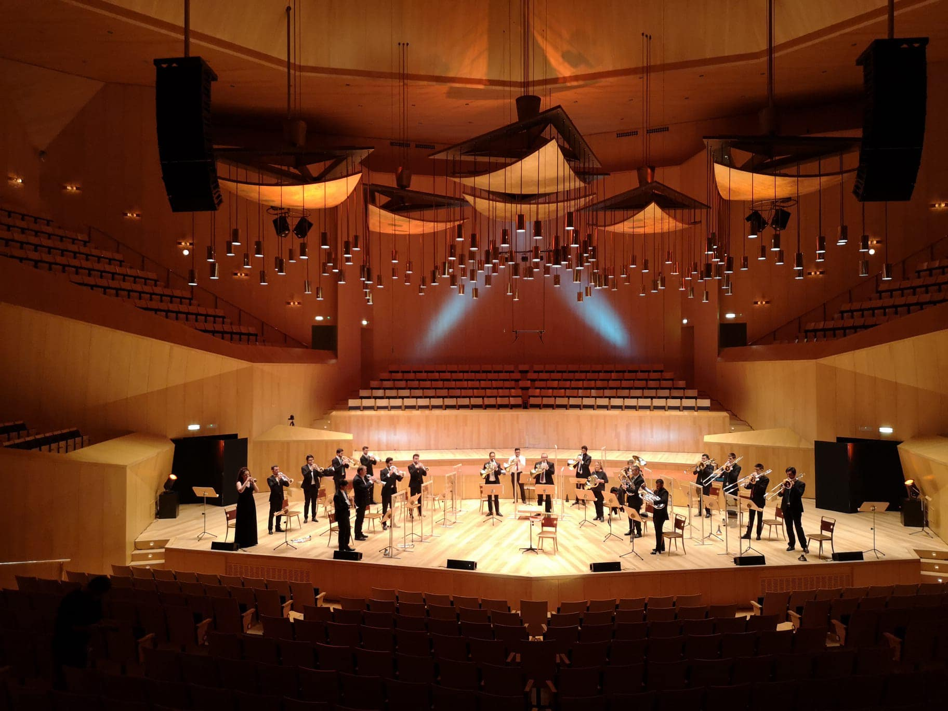

The group is active throughout Spain and Europe having performed in Madrid, ADDA in Alicante, Torrevieja, Murcia, Barcelona as well as taking part in the Schagerl Brass Festival in 2010 and 2011 at the iconic Monastery in Melk, Austria.

Since 2012 the group has been the ensemble in residence at the Alicante International Brass Festival having enjoyed working with soloists such as Gabor Tarkovi, Sarah Willis, Nury Guarnaschelli and Lito Fontana.

* ACADEMY SYMPHONIC BRASS
The Academy Symphonic Brass is the largest Brass group in the Academy and it was created in 2012. The group works under the guidance of Rudi Korp and Gabriel García Gutiérrez.
It is made of trumpets, horns, euphoniums, tubas and percussion.
.
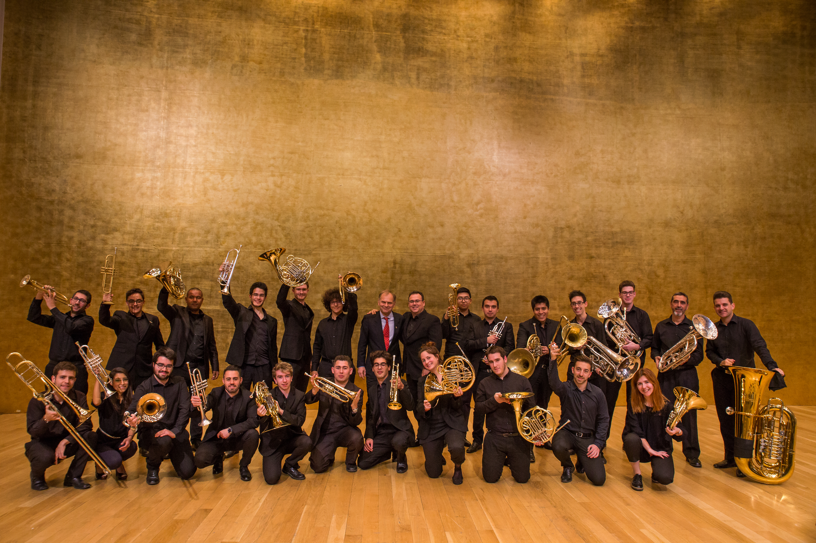
* BRASS ACADEMY HORNS
This horn ensemble within the BAA was created in 2009 in order to promote and study repertoire for this formation as well as working on passages taken directly from the orchestral repertoire. Nury Guarnaschelli directs the ensemble as principle professor of the academy and the group has performed on numerous occasions in the Alicante Summer Brass Festival.
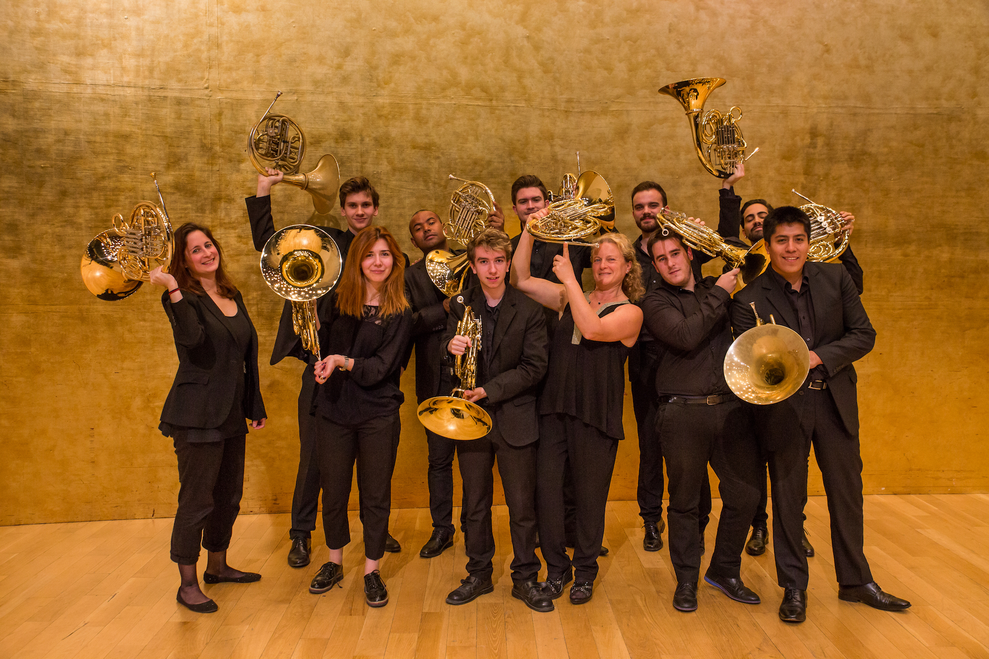

* BRASS ACADEMY TRUMPETS
This ensemble was formed to promote the rich and varied repertoire available for trumpets. The group is directed by Rudolf Korp, our founder and trumpet teacher.

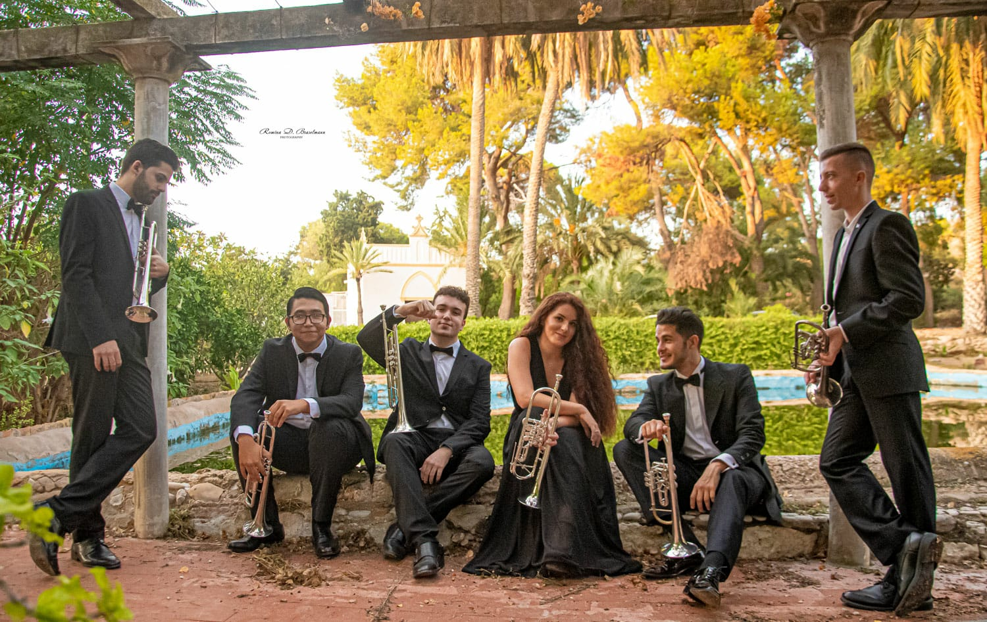

* BRASS ACADEMY LOW BRASS
This ensemble was formed to promote the rich and varied repertoire available for low brass instruments, trombones, euphonium and tuba. The group is directed by Patricio Consentino, Mark Hampson and Dani Perpiñan, all resident tutors for low brass at the BAA.
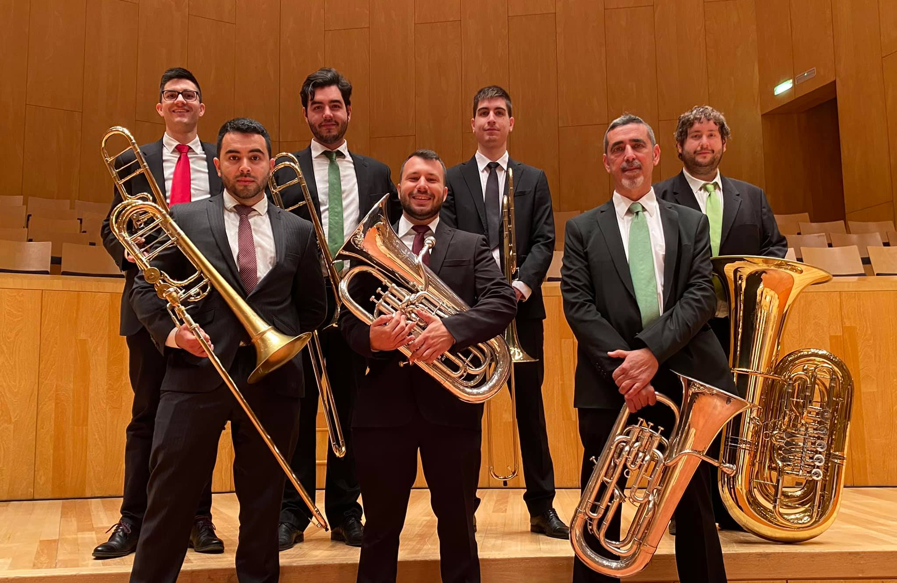

TERMS AND CONDITIONS OF REGISTRATION FOR THE ACADEMIC YEAR 2021-2022
Entrance auditions: 27 March 2021, in Alicante ( Avenida Ciudad de Matanzas Nº 5) or via video (uploaded to Youtube and sent to office@brassacademy.com until the 25 of March 2021
Certificates of study: Upon completion of the academic year at the Brass Academy Alicante, the artistic directors of the Academy present a Diploma of studies to the student, corresponding to the course of study completed in that year.
_____________________________________________________________________________
Open application period and granting of the “Brass Academy Alicante Scholarship” for 2021-2022:
Pre-requisites for scholarship consideration:
*No age limit.
Scholarships of diverse sums will be granted according to the score received in the entrance auditions (live and by video).
In order to obtain this scholarship, it is necessary to audition in person at the Brass Academy facility on March 27 2021 or to send a video (uploaded to YouTube) to the office@brassacademy.com email address, along with the registration form completed, with a digital photograph attached. The artistic committee decides on eligibility for a “Brass Academy Alicante Scholarship” according to their musical evaluation of the audition.
Important:
The students who have been accepted for Comprehensive Study and who possess a scholarship from another institution to study at the Academy are ineligible to receive to “Brass Academy Alicante Scholarship.”
*The scholarships will be reserved for those students who do not receive any other form of financial support.
_________________________________________________________________________
Explanation of the STUDY PROGRAMS:
Comprehensive study:
For TRUMPET, HORN, TROMBONE, EUPHONIUM and TUBA
This program is directed toward students age 16 and up with professional aspirations who seek a serious and rigorous program of study. It is also directed toward professionals interested in refining their technique, their interpretation, or who wish to train for competitions and auditions with our internationally renowned teaching staff.
For this program of study, the Academy offers individual lessons and participation in brass ensembles that perform concerts and study the performance of orchestral repertoire.
In this program, we give special importance to the preparation of orchestra musicians and the development of an excellent technique.
Tuition cost: 2500 Euros please see the information under each specific instrument heading.
Forms of payment for comprehensive study:
1st payment until 15 April 2020
The candidates admitted in the entrance auditions in 2021 must pay at least 500 euros as a registration deposit to reserve their place in the Academy, to be paid before 15 April 2020.
*This reservation payment will not be refunded in case of cancellation on the part of the student.
2nd payment: 500 euros, until 30 June 2021
3rd payment: the rest of the tuition, to be paid before 25 September 2021.

*ALGUNOS DE NUESTROS ESTUDIANTES PREMIADOS
- ANTONIO ZAMORA. Trompa
1º Premio. III Concurso Internacional Vicenta Zarzo en Valencia. 2015.
- DANIEL CLIMENT. Bombardino
1º Premio. IV Concurso Nacional de Tuba y Bombardino de Villajoyosa. 2015.
- MALAGA BRASS QUINTET – Quinteto metales
2º premio “ III Concurso nacional de música de cámara ciudad de la Vall d’Uixó.
- ALFONSO CANTÓ. Trompeta
1º Premio. Concurso “Villa de Cox”. 2014- MALAGA BRASS QUINTET – Quinteto metales
2º premio Muestra de jóvenes interpretes de Malaga 2014- SERGI MIÑANA. Trombón
3º Premio. VII Concurso de Villa de Castellnovo en Valencia. 2014.

- ANTONIO ZAMORA. Trompa
1º Premio. V Concurso de Jóvenes Intérpretes Rotglá i Corberá 2013.

- VANESA BAILÉN. Trombón
3º Premio. Concurso San Rapinya de Palma Mallorca. 2013.

- ELIECER CARO. Trompeta
1º Premio. Concurso Interpretación Vega Baja y el Boix Vinalopó. 2013

- ANTONIO ZAMORA. Trompa
2º Premio. IV Concurso Interpretes Rotglá i Corberá

- VICENTE CASCALES. Trombón
3º Premio. Certamen Comarcal de Interpretación Vega Baja Baix Vinalopó

- ALFONSO CANTÓ. Trompeta
1º Premio. Certamen Comarcal de Interpretación Vega Baja Baix Vinalopó

- ESTIBALIZ COLLADO. Trompeta
3º Premio. Certamen Comarcal de Interpretación Vega Baja Baix Vinalopó

- ÁLVARO GONZALEZ. Tuba
3º Premio. Certamen Comarcal de Interpretación Vega Baja Baix Vinalopó

- JOSÉ A. MARCO ALMIRA. Trombón Bajo
2º Premio. Certamen Comarcal de Interpretación Vega Baja Baix Vinalopó

- ROSARIO MENARGUES. Trompa
2º Premio. X Certamen Comarcal de Interpretación Musical Vega Baja – Bajo Vinalopó.

- JOSE Mª. GONZALEZ. Trombón
3º Premio. X Certamen Comarcal de Interpretación Musical Vega Baja – Bajo Vinalopó.

- SERGIO GARRIDO, Bombardino
1º Premio. XV Concurso Nacional de Jóvenes Intérpretes “Ciutat de Xàtiva” (Valencia).
- ALFONSO CANTÓ. Trompeta
1º Premio. Concurso “Villa de Cox”. 2014

- MALAGA BRASS QUINTET – Quinteto metales
2º premio Muestra de jóvenes interpretes de Malaga 2014

- SERGI MIÑANA. Trombón
3º Premio. VII Concurso de Villa de Castellnovo en Valencia. 2014.

- ANTONIO ZAMORA. Trompa
1º Premio. V Concurso de Jóvenes Intérpretes Rotglá i Corberá 2013.

- VANESA BAILÉN. Trombón
3º Premio. Concurso San Rapinya de Palma Mallorca. 2013.

- ELIECER CARO. Trompeta
1º Premio. Concurso Interpretación Vega Baja y el Boix Vinalopó. 2013

- ANTONIO ZAMORA. Trompa
2º Premio. IV Concurso Interpretes Rotglá i Corberá

- VICENTE CASCALES. Trombón
3º Premio. Certamen Comarcal de Interpretación Vega Baja Baix Vinalopó

- ALFONSO CANTÓ. Trompeta
1º Premio. Certamen Comarcal de Interpretación Vega Baja Baix Vinalopó

- ESTIBALIZ COLLADO. Trompeta
3º Premio. Certamen Comarcal de Interpretación Vega Baja Baix Vinalopó

- ÁLVARO GONZALEZ. Tuba
3º Premio. Certamen Comarcal de Interpretación Vega Baja Baix Vinalopó

- JOSÉ A. MARCO ALMIRA. Trombón Bajo
2º Premio. Certamen Comarcal de Interpretación Vega Baja Baix Vinalopó

- ROSARIO MENARGUES. Trompa
2º Premio. X Certamen Comarcal de Interpretación Musical Vega Baja – Bajo Vinalopó.

- JOSE Mª. GONZALEZ. Trombón
3º Premio. X Certamen Comarcal de Interpretación Musical Vega Baja – Bajo Vinalopó.

- SERGIO GARRIDO, Bombardino
1º Premio. XV Concurso Nacional de Jóvenes Intérpretes “Ciutat de Xàtiva” (Valencia).
* ENTREVISTA en TV
www.youtube.com/watch?v=wH0Jc7rvVdE&list=UUB4qtvN2thpFNPZwy06JdEg

* Video promocional BAA
www.youtube.com/watch?v=lp7gX80MhgA&t=8s

Brass Academy Alicante – www.brassacademy.com Tel. (+34) 658 57 51 36

